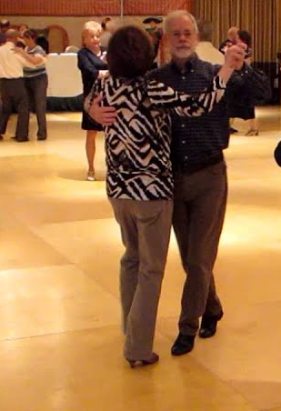  Round  Dancing  Square Dancing    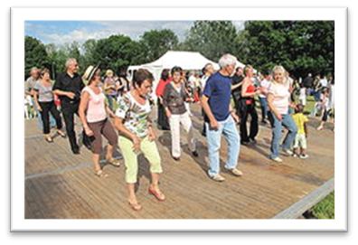  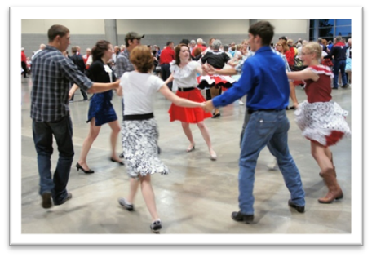  Line Dancing | ROUND DANCE -  choreographed  ballroom dancing,  couples progressing  around the dance hall  SQUARE DANCE –  (modern & social)  comprised of 4 couples  forming a square  LINE DANCE - single dancer, done in lines  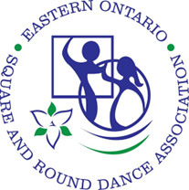  www.eosarda.ca & info@eosarda.ca |  |  | SQUARE, ROUND  & LINE DANCING  for fun, fitness  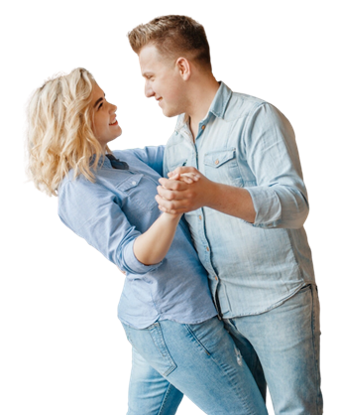  & friendship!  Eastern Ontario  Square & Round  Dance Association  www.eosarda.ca  info@eosarda.ca  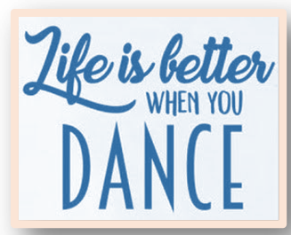  
Dance for FUN  - Dancing is fun and a great way to exercise without even realizing it.  - No experience or partner are required.  - Dancing within EOSARDA, a not-for-profit organization, is inexpensive.  - The caller/cuer/dance leader will teach everything you need to know in order to be a good dancer.  - There are no exams or competitions; we dance for fun, not for perfection!  - A wide variety of music is used to satisfy every ear!  - Casual attire and comfortable shoes are the only dress requirements.  - Dancing is a very social activity – you will make new friends, connect with old ones.  - Make dance night your DATE NIGHT -- get up and dance! |  | ..  Dance with FRIENDS    Dancing is  friendship set to music!  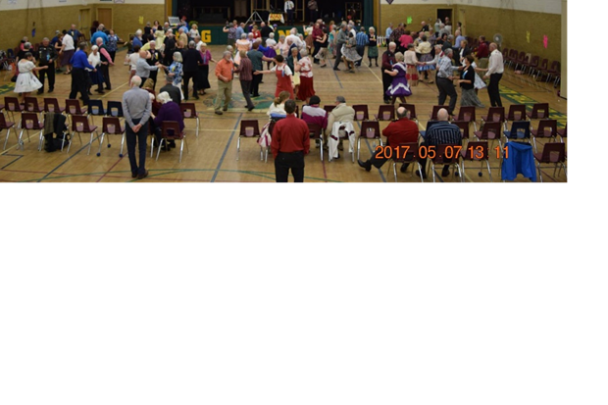  Contact: | .  Dance for FITNESS  - Visit Eastern Ontario Square and  Round Dance Association’s website  for info and to find a club near you: www.eosarda.ca.  - Especially check out the  ‘Interested in Dancing?’ page.  - Check us out on  /groups/eosarda.    & come square, round or line dancing!

